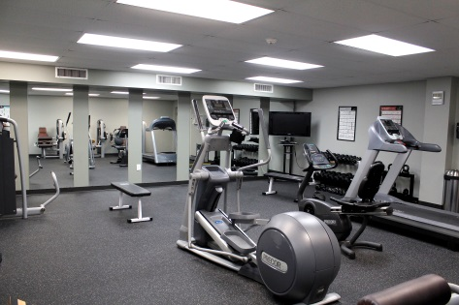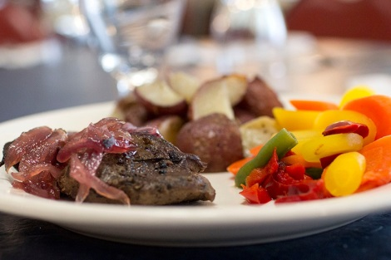

***HELPING YOU CONNECT WITH GOD AND EACH OTHER***

With [Special Guests – Speaker / Worship Leader]

To register [sign up at table in church foyer]

To get more information [call, email, website]

Cost

What to bring [Bible, notebook, modest one-piece swimsuit]

WWW.SANDYCOVE.ORG 800.234.COVE (2683)

WWW.SANDYCOVE.ORG 800.234.COVE (2683)

“Theme or Title”

Date of Event

Name of Event – can go to two lines with correct spacing